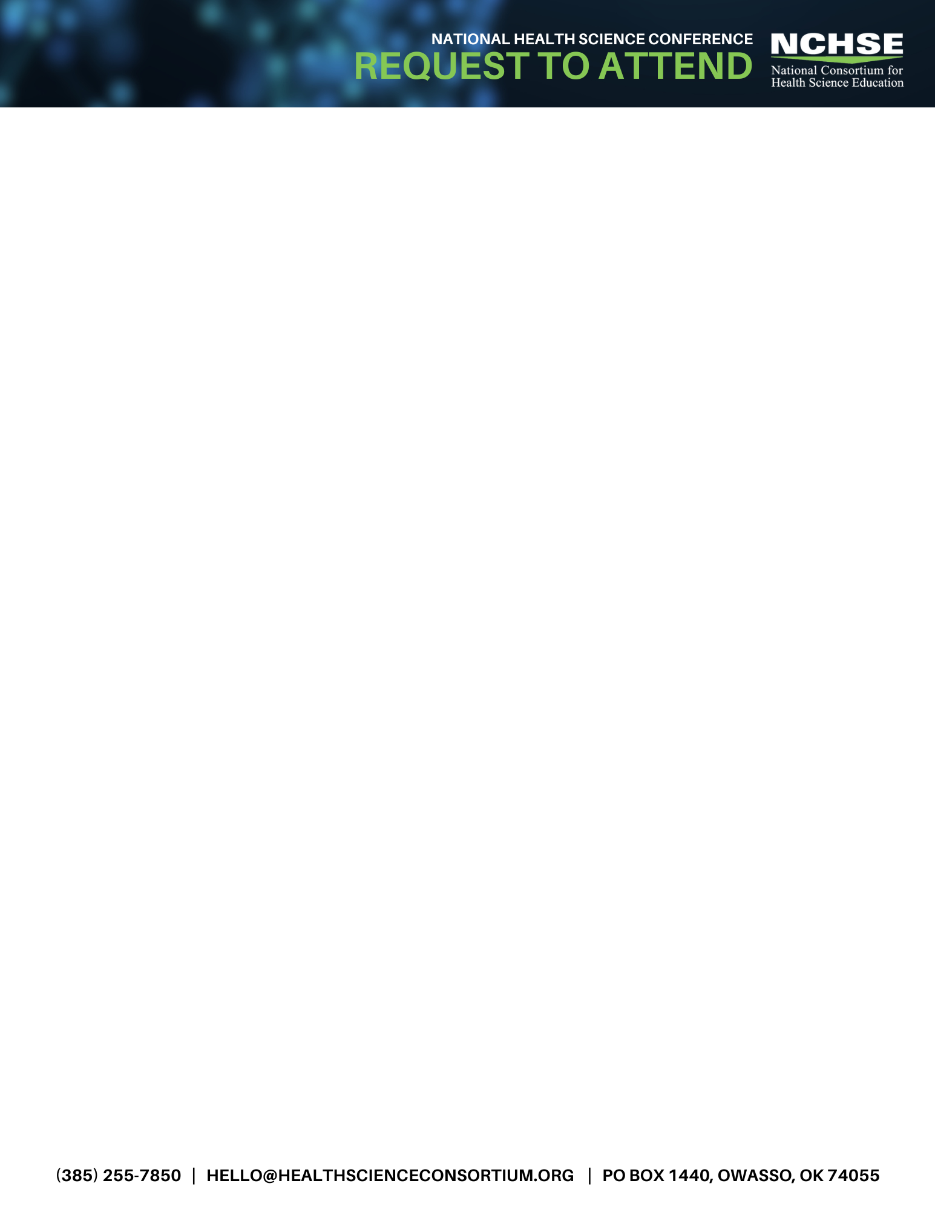
Subject: 2025 National Health Science Conference Travel Request
Date: <insert>

Dear <NAME>,

I would like to attend the upcoming 2025 National Health Science Conference, October 29-31, in Cincinnati, Ohio and the pre-conference session on October 28. This conference will feature sessions directly applicable to my work on <initiatives or project(s) you are working on> and is the only nationwide conference that is 100% focused on health science education.

The National Consortium for Health Science Education (NCHSE) sponsors this annual conference that includes in-depth health science program sessions, demonstrations of instructional resources, and hands-on workshops. The conference will also provide networking opportunities with my peers and others committed to preparing students for health professions. It is a great opportunity to gain first-hand insights on < name subject areas or specific products interested in > from breakout sessions, keynote speakers, exhibitors and sponsors, and one-on-one meetings with the experts.

I am seeking support for the registration fee, travel expenses, hotel accommodations and meals, during my stay in Glendale. Approximate costs for the National Health Science Conference are outlined below. This appears to be an incredible value considering the comprehensive array of topics which will be offered. Full details are found at: https://healthscienceconsortium.org/conferences/

Review categories in the preceding paragraph and add details below. Adjust appropriately for your travel needs. Travel costs will vary. Insert amounts in the brackets to reflect your expenses. Add or remove any items from the suggested list below.

A breakdown of the conference costs follows:
2025 National Health Science Conference
Hilton Netherland Hotel, Cincinnati, OH
– Tuesday, October 28 pre-conference session
– Wednesday - Friday, Oct 29-31 full conference
A breakdown of the conference costs follows:
- Airfare: <add flight expenses>
- Mileage: <if driving and if requesting mileage reimbursement to and from airport>
- Parking: <if parking at airport > (On-Site Hotel Parking: Daily: $39 self parking, $45 valet)
- Transportation to/from Airport: Shared ride: $25-35
- Hotel: <add actual> (Conference rates: $185/night; excluding taxes and fees)
Hilton Netherland Hotel
- Meals: <add actual> (Registration fee includes three breakfasts, two lunches, and breaks. Pre-conference includes breakfast, lunch, and breaks.)
- Early Bird Conference Registration Fee: $575.00/ Pre-conference Registration Fee: $175.00
If an attendee submits a presentation proposal and is selected to present, the primary presenter receives a $100.00 registration discount.
- After Early Bird rates expire: Conference registrations increase to $675.00 August 16-September 26 and then $775 September 27 on; Pre-Conference registration increases to $225 August 16-September 26 and then $275 September 27 on
- Total: < Insert total>

The National Health Science Conference presents an opportunity to enhance my teaching skills while strengthening contacts with others from across the nation. My attendance will be an investment in my professional growth, which will translate into the delivery of a quality health science education program at our school through the inclusion of best practices, real-world solutions, and a network of peers.

It would indeed be an honor to attend this outstanding conference on behalf of <insert your program/school>. I look forward to your reply.

Sincerely,
Insert Name

